1. Calculate the average public expenditure for the year 2005 across all countries.

OUTPUT:

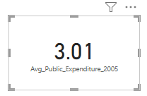

STEPS:

* Go to Report View > Click on 3 dots right of expenditure dataset > click on **“new measure” >** Enter the DAX such as:

Avg_Public_Expenditure_2005 =

AVERAGEX( FILTER

(ExpenditureData, ExpenditureData[direct_expenditure_type] = "public"), ExpenditureData[2005]

)

* Go to visualization pane > Insert a Card > Drag the measure **Avg_Public_Expenditure_2005** into it.

2. Calculate the total publications for institutions in the UK.

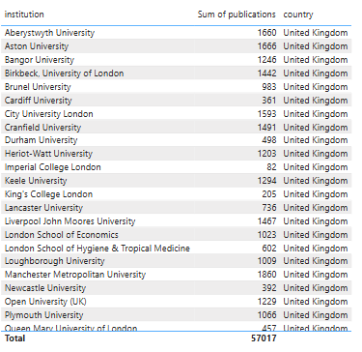OUTPUT:

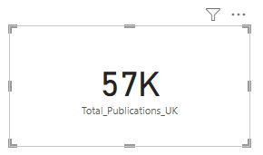

STEPS:

1. Add a **Table visual**
2. Drag institution and publications into the “data” table
3. In **Filters pane**, drag country → Filter to **UK**
4. To get total: Add a **New Measure** in data table:

Total_Publications_UK =

CALCULATE(SUM(InstitutionData[publications]), InstitutionData[country] = "United Kingdom")

1. Use a **Card visual** to show the total.

3. Filter the dataset to show only institutions with a world rank below 100.

OUTPUT:

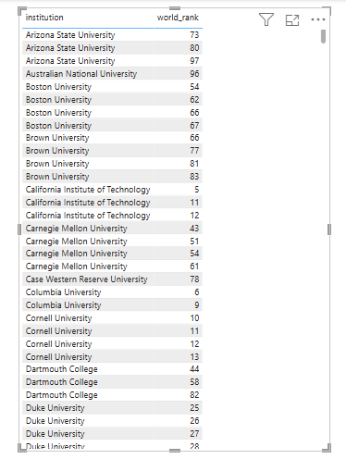

STEPS:

1. Add a **Table visual**: Add columns: “institution”, “world_rank”
2. In **Filters**, drag world_rank → set condition to **less than 100**

**4.** Calculate the total expenditure for all years for each country.

OUTPUT:

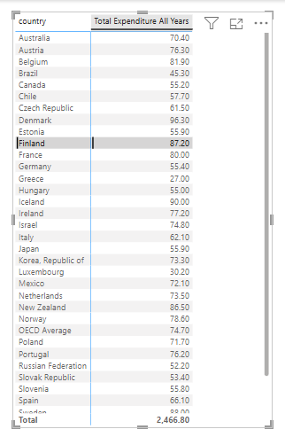

STEPS:

1. Select Expenditure table > Click "New Column" and create calculated columns for each year

* Total_1995 = Expenditure[1995]
* Total_2000 = Expenditure[2000]
* Total_2005 = Expenditure[2005]
* Total_2009 = Expenditure[2009]
* Total_2010 = Expenditure[2010]
* Total_2011 = Expenditure[2011]

1. Create a new measure in expenditure column:

Total Expenditure All Years = SUM(expenditure[Total_1995]) + SUM(expenditure[Total_2000]) + SUM(expenditure[Total_2005]) + SUM(expenditure[Total_2009]) + SUM(expenditure[Total_2010]) + Sum(expenditure[Total_2011])

1. Add Matrix visual > Drag "country" to Rows > Drag "Total Expenditure All Years" to Values (*Note - One can add Tabel visual also)

5. Write a DAX formula to ignore any filters on the year column and calculate the total score across all years.

OUTPUT:

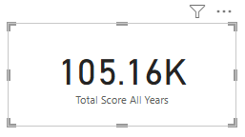

STEPS:

1. Go to report view > In **“data”** table, Create new measure:

* **Total Score All Years = CALCULATE(SUM(Data[score]), ALL(Data[year]))**

1. Add Card visual and place this measure in it

6. Calculate the growth in expenditure for Austria from 1995 to 2000.

OUTPUT:

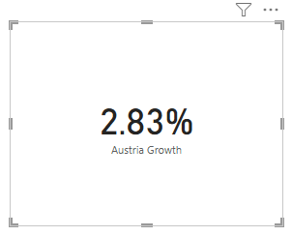

STEPS:

1. Go to report view > In expenditure column, Create new measure:

Austria Growth = VAR Expenditure2000 = CALCULATE(SUM(Expenditure[2000]), Expenditure[country] = "Austria")

VAR Expenditure1995 = CALCULATE(SUM(Expenditure[1995]), Expenditure[country] = "Austria")

RETURN (Expenditure2000 - Expenditure1995)/Expenditure1995

1. Go to format visual > Format as percentage
2. Add Card visual and place this measure in it

7. Format the expenditure values to include a currency symbol and zero decimal places.

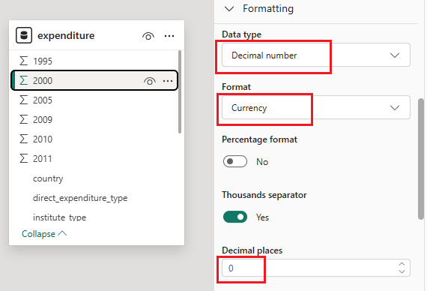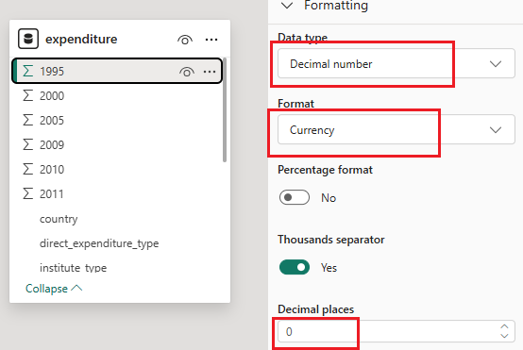OUTPUT:

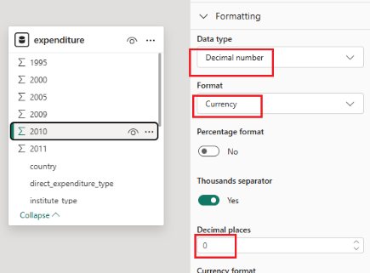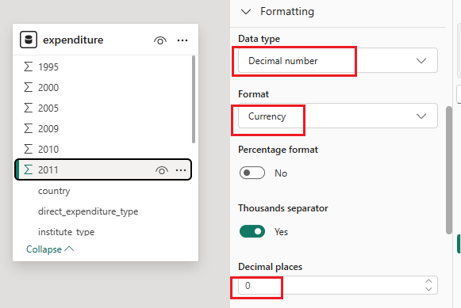

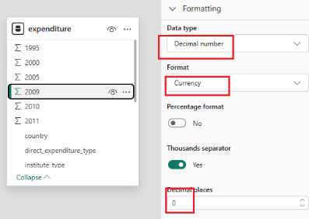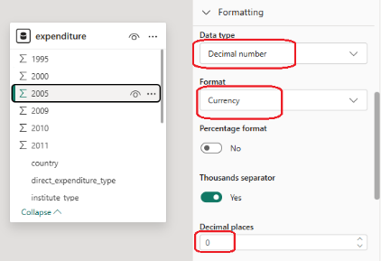

STEPS:

* Go to Model view
* Select Expenditure table
* For each year column (1995, 2000, etc.)
* In the Properties pane, change the **Data type** to **Decimal Number**
* Under **Format**, choose **Currency**, then set decimal places to **0**

8. Calculate the total expenditure for each country.

OUTPUT:

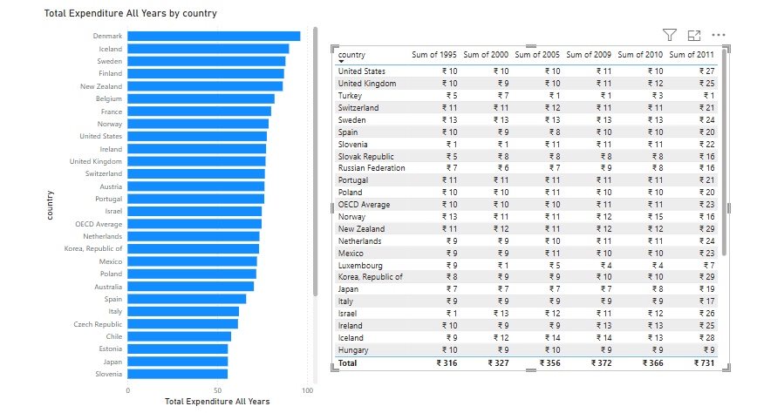

STEPS:

* Use the **“Total Expenditure”** column from **Task 4**
* In report view, Add a **Stacked** **Bar chart**: Y - Axis = country, X - Axis = Total_Expenditure.
* In report view > Add Table visual
* Drag "country" from Expenditure to Values
* Drag each year column to Values
* Power BI will automatically sum them

(If you hover over bar chart it will show total expenditure for each country.)

9. Create a report showing each visual in different sheets:

(a) Break down the total patents of institutions by country and then by quality of faculty. Analyze which factors contribute most to the number of patents across different countries.

OUTPUT:

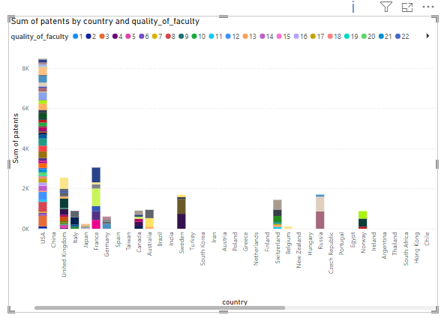

STEPS:

* In Power BI **Report view**, go to the **Visualizations** pane
* Click on **Stacked Column Chart**
* Drag **country** → drop into **X-Axis**
* Drag **patents** → drop into **Y-Axis**
* Drag **quality_of_faculty** → drop into **Legend**

(b) Use the Q&A feature in Power BI to answer the question: "What is the total

publications and citations for institutions in the USA?" and display the results in a

table and bar chart format.

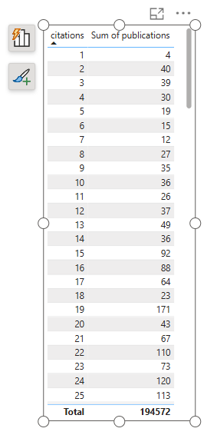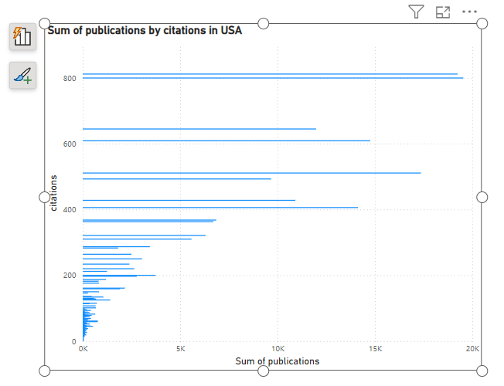OUTPUT:

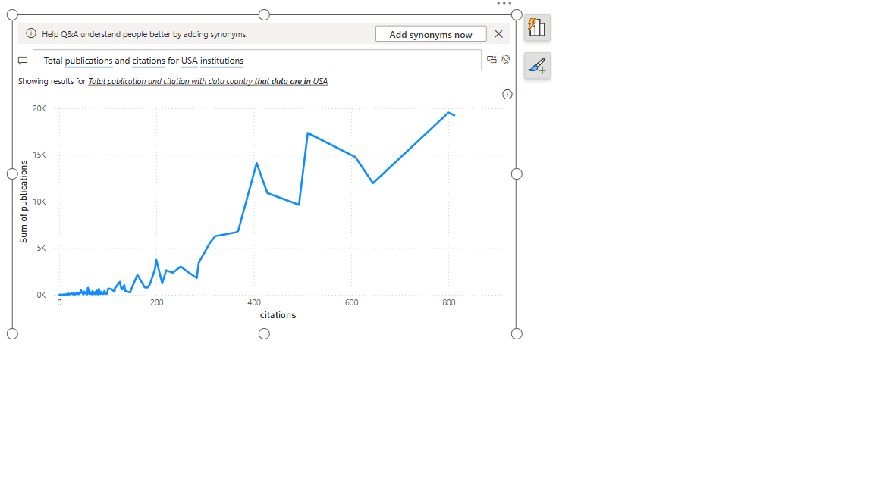

STEPS:

* In report view, Insert a **Q&A Visual** > Ask: Total publications and citations for USA institutions
* Power BI will create visualization > Duplicate visual (Copy & Paste)> change to table format
* Repeat step for creating bar chart

(c) Display key metrics for the top 5 institutions by world rank, including fields such as institution, country, score, and national rank.

OUTPUT:

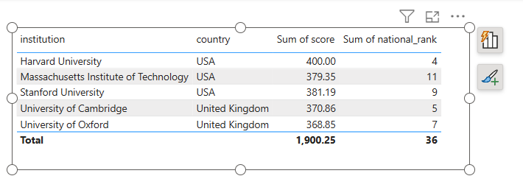

STEPS:

In Report view, Add Table visual

* Add fields: institution, country, score, national_rank

In **Filters pane**:

* Drag institution to **"Filters on this visual"**
* Choose **"TOP N > Bottom > 5"** from the filter type (Bottom will give upper ranking)
* In the **"By value"** field, drag in world_rank
* Click **Apply filter**

(d) Represent the distribution of direct_expenditure_type (e.g., public vs. private) for the year 2011 across all countries. Highlight the OECD Average as a separate segment.

OUTPUT:

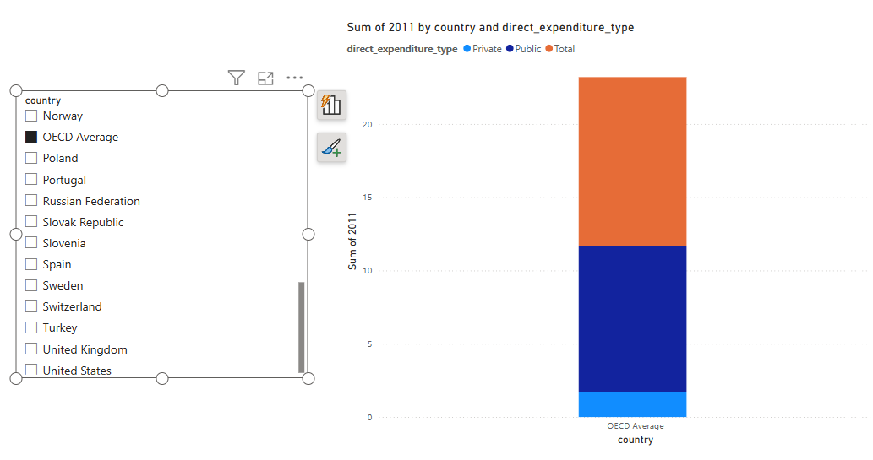

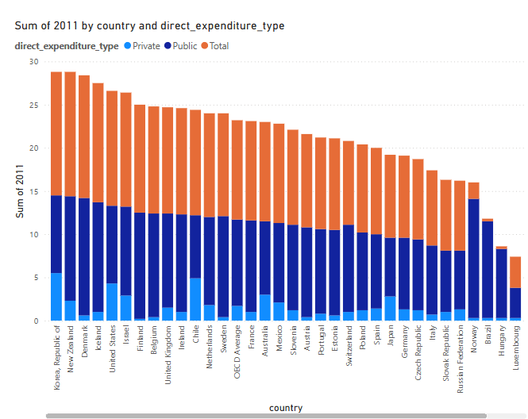

STEPS:

* Drag & Drop Stacked Column Chart > X-axis: country > Y-axis: 2011 (sum) > Legend: direct_expenditure_type
* Add a **Slicer visual** next to column chart > Select country column > Now, you'll see a list of countries > **Click only on "OECD Average"** → This filters your chart to show just that bar

10. Create a workspace "Institution Analysis" and set up a schedule to refresh the datasets every day at 6 AM.

OUTPUT:

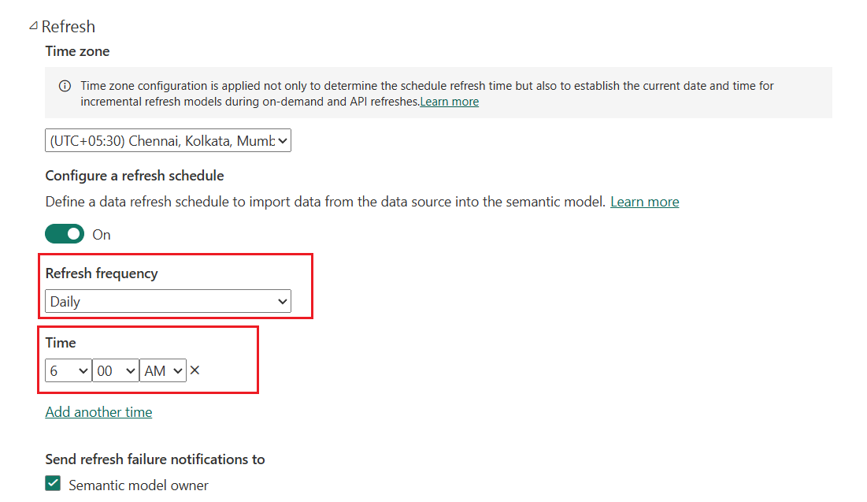

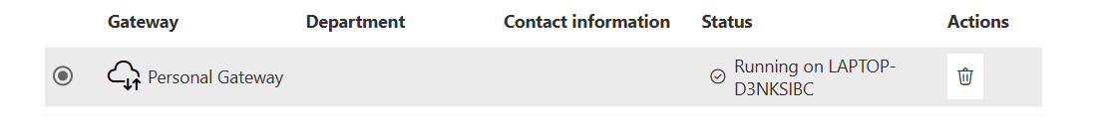

STEPS:

Go to PowerBi service > **Log in** with your Microsoft/Power BI account > In the left pane, click **“Workspaces”** > Click **“+ New workspace”** > Set the name as: Institution Analysis > Click **Save**

Now Go to PowerBi desktop > Click **File > Publish > Publish to Power BI** > Select the workspace you just created: **Institution Analysis**

**In Power BI Service:**

1. In the left menu, go to **Workspaces > Institution Analysis**
2. In the top bar, Click download > Data Gateway > Download and install it also sign in using same credentials > In powerBi settings, Gateway will show status as running
3. Go to **Settings > PowerBI settings >** Scroll down to **Scheduled Refresh** > Turn **"Keep data updated" = ON**
4. Under **“Scheduled refresh”**:
   * **Time Zone**: Select your local timezone
   * **Add time**: Type or choose 6:00 AM
   * Click **Apply**